Discussing the impact of emotional labour on teachers based on interactive devices

Author: Songyang Shao

Supervisor: Yadira Sanchez

Msc Creative Computing

November 23, 2023

Presentation video link: https://youtu.be/IYVI5ZOX0R8

Word count: 5114

Abstract

This study, grounded in the framework of Critical Technical Practice, investigates the emotional labour in teaching, focusing on both its surface and deep performances. It engages with the nuances of emotional labour through interactive devices, examining the outward display of emotions (surface performances) and the alignment of internal feelings with external expressions (deep performances). The research highlights the emotional toll and coping mechanisms in the teaching profession, an area often overlooked. By analyzing the dynamics of emotional labour, this paper aims to foster a deeper understanding and critical reflection on its impact in education.

1. Introduction 4

2. Related Work 6

2.1 Emotional labour and emotional labour in the field of education 6

2.2 The role of interactive devices in expressing social issues 8

3. Methodology 10

4. A Project Write Up 11

4.1 Installation Design Inspiration 11

4.2 Installation design process 12

5. Evaluation 16

5.1 Self-assessment 17

5.1.1 Technical Realisation 17

5.1.2 Artistic Value 17

5.2 User experience feedback 18

5.2.1 Record of questions and answers 19

5.2.2 Feedback summary: 21

6. Discussion 21

6.1 Technical Contribution 21

6.2 Aesthetic Contribution 23

7. Conclusions & Future Work 23

1. Introduction

Since the mid-twentieth century, coinciding with the rise of the post-industrial era, the prominence and share of the service industry in societal production have escalated progressively. A key characteristic of the service sector is the provision of services by employees to customers, where the quality of these services and the resultant customer satisfaction have become pivotal factors influencing organizational efficiency. The emotional aspects of employee-customer interactions, such as language, expression, and attitude, significantly impact customer experience and mood, thereby directly affecting operational efficiency. There will undoubtedly be many occasions when the emotions that the worker wishes to display are not the same as those that s/he genuinely feels (Mann, 2004). Consequently, 'emotional labour', a form of labour that encompasses emotional investment to support production and management processes, has emerged as a third category alongside physical and mental labour.

Teaching is a profession of emotional labour (Kariou et al., 2021). The emotional stability and positivity of teachers play a vital role in stimulating student interest and enhancing the efficacy of teaching and learning. Conversely, emotional instability and negativity in teachers can adversely affect students. Teaching is an emotional endeavor (Yin, Huang and Chen, 2019). Managing one’s own feelings in order to manage others’. It’s work that is often invisible and almost always undercompensated—and it’s also really, really hard (Hochschild, 2022, pp.40–48). Thus, emotion management in teachers holds substantial importance and value in educational contexts. With the progression of universal and inclusive education, the demand for emotional labour intensifies as teachers navigate diverse student backgrounds and needs. Educational reforms, with evolving teaching methodologies and philosophies, add to the emotional burden of teachers. Moreover, the increasing curricular demands compel teachers to focus not only on academic instruction but also on the holistic development of students, further amplifying emotional labour. Particularly in primary and secondary education, where students undergo rapid emotional and psychological development, the requirement for teachers to exhibit emotional stability and adept management of their emotions is paramount. The success of those marginalised students often requires a great deal of emotional labour on the part of the teaching staff (Shayne, 2017). This is essential not only for influencing students towards balanced emotional and psychological states but also for maintaining healthy teacher-student relationships.

The emotional state of teachers also significantly impacts their own mental health (Glazzard and Rose, 2019). Given the high societal regard for the teaching profession, teachers often face potential stress from societal, student, and parental expectations. The emotional labor of teaching is real. If we don't discuss and deal with this issue, it will start to percolate and turn into dissatisfaction and inefficiency, which will evolve into depression and ultimately burnout. (Previte, 2020). In 2019, an article in Tomorrow magazine, guided by the Chinese Association for the Development of Teacher Education, presented an analysis of teachers' mental health issues. The study, based on interviews and questionnaires, found that 32.4% of surveyed teachers experienced considerable work-related stress. Notably, 61.2% of primary and secondary school teachers exhibited signs of anxiety, manifesting in poor social adaptability, interpersonal tensions, emotional instability, and fluctuating self-esteem. Emotions are an integral part of education and of organizations more generally (Hargreaves, 2000). Such a state of mental health in teachers directly influences the quality of teaching and, over the long term, may lead to attrition among competent educators. Positive emotions and negative emotions were found to be significant moderators between the relationship of teachers' stress and job satisfaction (Parveen and Haleema, 2019).

Attempts to separate emotions from or to join them with teaching practice have implications for teacher identity and development (Schutz, 2009). Therefore, the recognition and understanding of teachers' emotional labour are imperative. This paper employs an interactive device to visualize and demonstrate the dynamics of teachers' emotional labour. Serving as a discursive tool, it aims to enable the audience to experientially comprehend and critically reflect upon the process and implications of teachers' emotional labour.

1. Related Work

2.1 Emotional labour and emotional labour in the field of education

Emotional labour is when an individual manages his or her emotions to create facial and bodily expressions that are observable to the public (Arlie Russell Hochschild, 2012). This concept is particularly salient in the field of education, where teachers are required not only to impart knowledge but also to adeptly manage their emotions to foster student interest and engagement. This encompasses maintaining a positive emotional atmosphere within the classroom, as well as providing emotional support and encouragement to students. The articulation of emotions such as understanding, encouragement, and enthusiasm by teachers is pivotal in establishing an optimal learning environment.

Emotional labor has always been a characteristic of teaching (Kariou et al., 2021). Teachers are often called upon to display patience, empathy, and encouragement, even under the pressures of addressing the diverse needs and challenges of individual students. However, such emotional expressions may not always be instinctive. Teachers frequently resort to 'surface acting,' which involves exhibiting an emotion outwardly without genuinely experiencing it internally, or 'deep acting,' which entails aligning one's internal feelings with the outward emotional display. This form of emotional labour significantly influences teachers' mental health and efficacy in teaching. Teachers' habitual patterns of judgement about student behaviour and other teaching and learning tasks may lead to repeated experiences of unpleasant emotions, and the end result of these emotions may lead to teacher burnout (Chang, 2009). Prolonged engagement in emotional labour can lead to emotional exhaustion, adversely affecting job satisfaction and psychological well-being of educators (Anttila et al., 2017).

Emotional labour has always been an integral aspect of the teaching profession and is a critical discovery in the context of contemporary society. Emotions serve as the nexus between external objective influences and the subjective needs of an individual. The escalation of emotional labour is an inevitable byproduct of the burgeoning development of the service industry. Teachers' emotional labour, specifically, refers to the process whereby educators, as school personnel, adhere to national and institutional guidelines for emotional management, dedicating themselves to education and teaching. Research has also shown that the performance of emotional labour is an important aspect of the reality of teaching and learning and has an impact on the physiological and psychological aspects of teachers. (Isenbarger and Zembylas, 2006). Investigating and understanding teachers' emotional labour not only enriches the understanding of the nature of teachers' work but also provides a vital avenue for enhancing the physical and mental well-being of teachers, fostering harmonious teacher-student relationships, optimizing school management, and augmenting the overall quality of education. Therefore, knowledge of teachers' emotions is essential in understanding teachers and teaching (Sutton and Wheatley, 2003).

Recent scholarly discourse within the educational sector has increasingly recognized teachers as practitioners of emotional labour. This recognition aligns with the three characteristics of the emotional labour industry delineated by Hochschild. Firstly, the teaching profession is characterized by extensive interpersonal interactions between teachers and students. Secondly, the emotional expressions of teachers substantially influence student learning and engagement. Thirdly, societal and institutional norms mandate that teachers effectively regulate and control their emotions. In light of these aspects, delineating the nature and function of teachers' emotional labour, refining emotional labour strategies, mitigating its adverse effects, and augmenting its effectiveness have emerged as salient themes in educational research.

From my personal perspective, education is inherently an interactive endeavor, wherein emotional exchanges between teachers and students play a pivotal role in the efficacy of teaching and learning processes. Effective emotion management by teachers is crucial for fostering a positive and stimulating classroom environment. The emotional states of educators directly impact students’ emotional reactions and learning motivation. Positive emotional expressions from teachers can enhance students' learning interest, whereas negative emotions may create learning impediments and resistance. Moreover, teachers are expected to navigate the emotional expectations set forth by society and educational institutions. This necessitates robust emotional regulation skills, enabling teachers to adapt to diverse teaching contexts and meet varying student needs.

Thus, understanding and enhancing teachers' emotional labour strategies, alleviating its negative repercussions, and improving its overall effectiveness are imperative areas of focus in contemporary educational research. These efforts are anticipated to not only elevate teaching efficacy but also contribute to teachers' professional fulfillment and psychological well-being.

2.2 The role of interactive devices in expressing social issues

Most paintings, due to their inherent limitations, are unable to effectively engage the viewer on a deep psychobiological level (Konečni's 2015). Instead, their appreciation frequently centers on aesthetic qualities rather than eliciting significant emotional responses. In contrast, art installations, leveraging a confluence of stimuli, actively engage viewers both physically and cognitively, often inducing deep emotional reactions, including a sense of 'aesthetic awe'. Konečni delineates 'aesthetic awe' from basic emotions like joy or fear, describing it as a complex derivative emotion intertwining elements of pleasure and fear, contingent upon a sense of security and control over the fear-inducing aspects. This nuanced emotional response, unique to the context of art installations, can be deliberately modulated by the viewer, distinguishing it from responses elicited by other art forms.

Furthermore, Konečni's Aesthetic Trinity Theory (ATT) underscores the distinction between the emotional impacts of art installations and paintings. ATT suggests that installations, due to their design and the nature of stimuli they present, are inherently more likely to evoke 'aesthetic awe'. This theory identifies three crucial characteristics of artworks that enhance this effect in installations: psychophysical characteristics (such as size), statistical characteristics (including rarity, complexity, novelty), and ecological characteristics (encompassing both positive and negative reinforcement).

On a parallel trajectory, Philip E. Agre's concept of Critical Technical Practice (CTP), established in 1997, transcends the traditional perception of computers and technology as mere tools. CTP recognizes the profound political, cultural, social, and economic impacts of technology, emphasizing the necessity of ethical considerations in technological applications. It involves a critical examination of the internal dynamics within project teams and the broader implications of technology on societal structures.

In this vein, my research incorporates CTP to investigate the techno-social aspects of contemporary digital culture within the educational sphere. This approach entails an artistic examination of socio-technical environments, treating software as an object of technology, culture, and human relations. It blurs the boundaries between technological theory, practice, and interpersonal relationships, fostering a critical exploration of various facets of technology.

Consequently, this paper examines the emotional labour in teaching as a socio-technical phenomenon. It focuses on the intersection of technical aspects of teaching (such as educational techniques and methods) with the emotional and interpersonal dimensions of the profession. Utilizing the ethical framework provided by CTP, this study aims to uncover and analyze aspects of teaching practice and the impact of emotional labour involved, thereby contributing to a deeper understanding of the emotional dynamics in educational settings.

1. Methodology

In this study, I employed Critical Technical Practice (CTP), a methodology pioneered by Phil Agre, to elucidate the influence of interactive devices on the personal dynamics of emotional labour. CTP transcends the mere technical aspects of technology, delving into its profound effects on cultural, social, political, and personal spheres. This approach underscores the indissoluble bond between technology and societal contexts.

The installation at the heart of this project is an amalgamation of technology, critical theory, and art. It aims to bridge the theoretical and practical realms of technology, placing a spotlight on the real-time techno-social facets of contemporary digital culture. A quintessential aspect of CTP involves the creation and exploration of tangible projects or propositions to elucidate phenomena, emphasizing reflective processes. Therefore, I explained and demonstrated the phenomenon of teachers' emotional labour through an interactive installation, which allowed the audience to have a first-hand experience of the topic, deepened their understanding of the present of teachers' emotional labour, and highlighted the profound impact of emotional labour on educators.

The design of this interactive installation incorporates technology, art and critical social theory. This blended approach helps to examine and communicate the nature and impact of emotional labour and sheds light on the often overlooked emotional labour and its impact on teachers. The goal of this research is to provide a comprehensive breakdown and demonstration of emotional labour, while also providing a platform for reflection and interpretation by the audience.

1. A Project Write Up

4.1 Installation Design Inspiration

Emotional labour, particularly in the teaching profession, can be conceptualized as a dynamic process of absorption and subsequent transformation. Educators often engage in the absorption of less positive, sometimes negative emotions, which are then transmuted into positive emotional outputs for the benefit of students. Conversely, this process can also entail the assimilation of positive energy, which may be converted into more solemn or neutral expressions. This dual process of absorption and transformation bears a striking resemblance to the physical phenomenon of refraction observed in optics.

Refraction is defined as the alteration in the path of light as it transitions between different media. This shift in trajectory necessitates light to undergo specific adaptations and adjustments contingent on the medium it traverses. Analogously, in the realm of emotional labour, educators must adeptly navigate and adjust their emotional responses based on the situational context. Just as light alters its course to maintain its propagation across diverse media, teachers modulate their emotional expressions, adapting to the emotional and psychological landscapes of their students. This metaphor not only enriches our understanding of the complexities inherent in emotional labour but also underscores the nuanced adaptability required of educators in their professional roles.

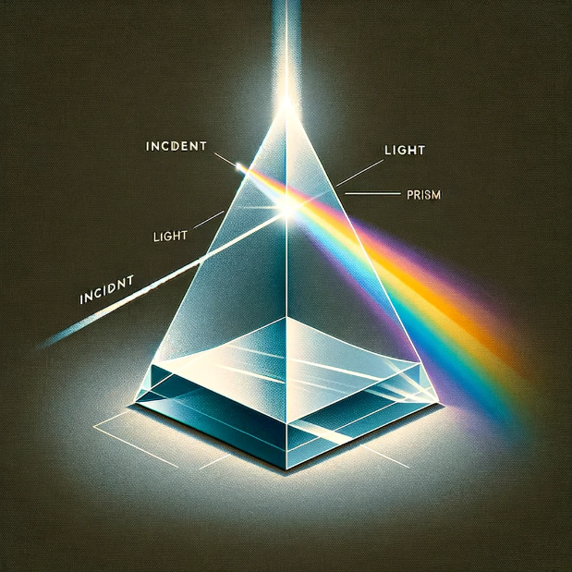 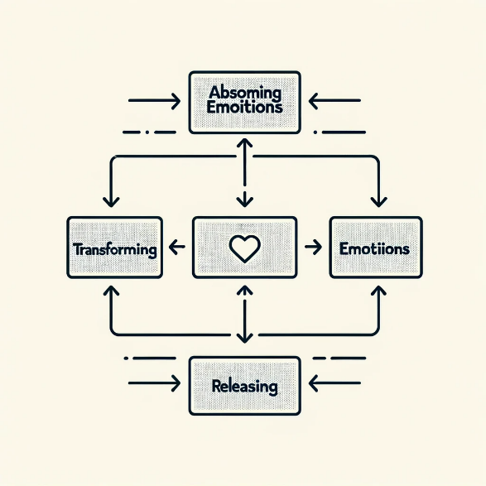

Refraction of light through a prism The process of emotional labour

4.2 Installation design process

The interactive installation devised for this research embodies the principles of Critical Technical Practice (CTP), a methodology which merges technical prowess with artistic inquiry, aiming to scrutinize the techno-social fabric of the digital age. This installation operationalizes CTP by using a distance sensor to actuate a servomotor linked to a prism. The prism's rotation, instigated by the participant's interaction, symbolizes the intricate process of emotional labor—emphasizing the absorption, transformation, and eventual release of emotions by educators.

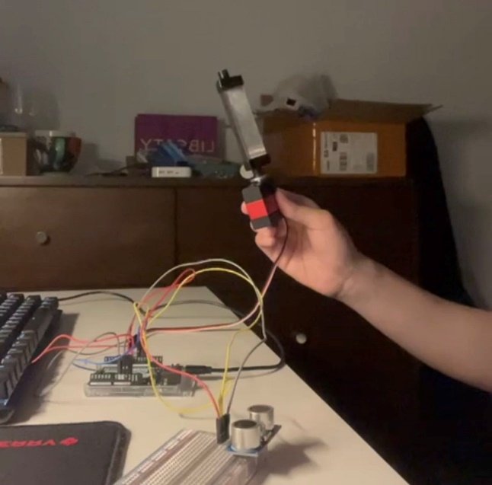 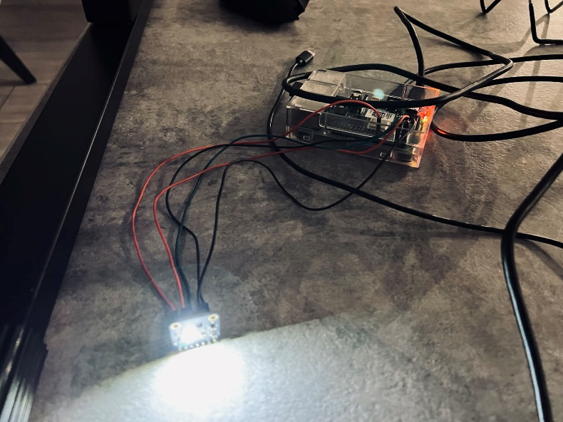

Distance sensor & sevor RGB color sensor

As per CTP's pedagogical stance, the embodiment of emotional labor through this interactive medium serves as a critical examination of the socio-technical systems at play within the pedagogical domain. The projection of refracted light onto an RGB color sensor, which then triggers video playback on a Raspberry Pi system, illustrates the transformative nature of emotional labor. This transformation is analogous to the refraction phenomenon, a metaphor for the modification of emotional states by teachers in their professional conduct.

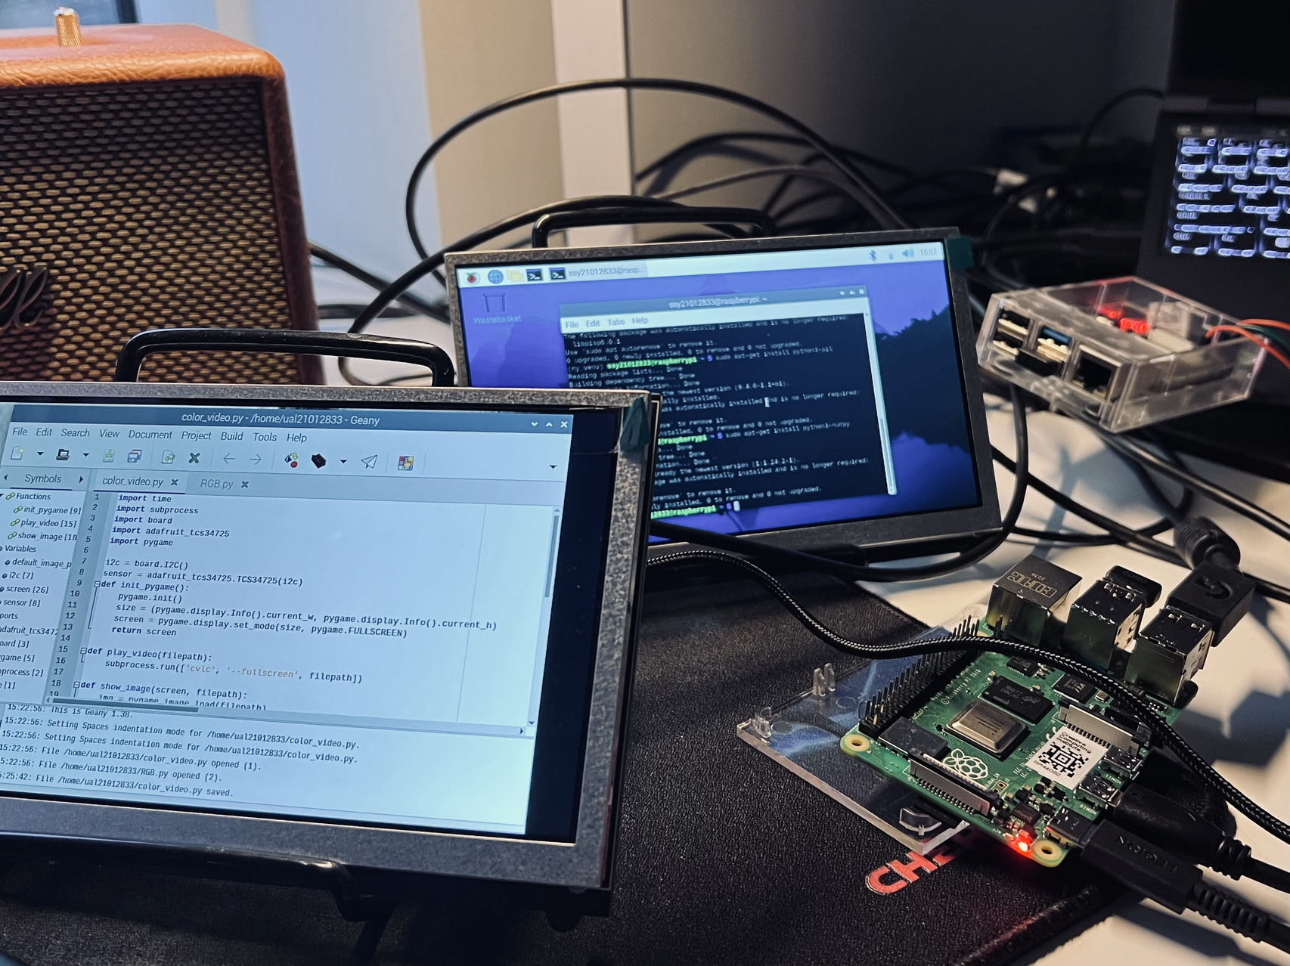

Raspberry Pi setup & video playback control 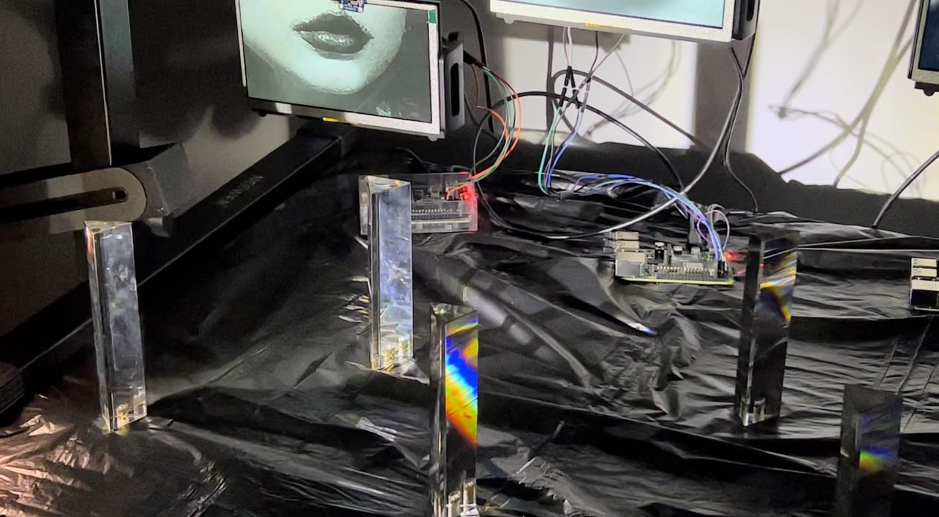

Light refracted by a prism

Everyone knows what a smiley face means. But real smiles are another story and not always a happy one (Rychlowska et al., 2017). Comparable to the universal appropriateness of a little black dress or a classic suit in fashion, the act of smiling presents itself as a versatile and fitting response across a spectrum of social scenarios. These scenarios may range from the emotionally positive, such as reuniting with a close friend, to contexts characterized by social discomfort or public humiliation. This phenomenon underlines the complexity of the smile as a social signal. While conventional understanding aligns smiling with the expression of positive emotions, there exists a broader spectrum of emotional states that elicit this response. Individuals have been observed to smile not only during moments of happiness but also in instances of misery, discomfort, or embarrassment. This duality in the function and interpretation of smiling reflects its intricate role in human social interactions and emotional expression.

The selection of micro-expressions, specifically smiles, as the thematic nucleus of the video content, is a strategic artistic decision in line with the CTP approach. The utilization of Midjourney and Runway tools to generate these expressions is a conscious integration of art and technology, serving as an exploratory lens into the nuances of emotional labor.

This project's conflation of technical and artistic methodologies is reflective of CTP's core objective: to engender a multifaceted understanding of technical artifacts and their socio-emotional ramifications. It also extends the discourse of emotional labor within the educational sector, placing educators at the intersection of emotional exchange and technological mediation.

 

Produced by Midjourney Produced by Midjourney

 

Pinterest—Runway Real Photos--Runway

In the initial phase of video production, I explored the utilization of Pinterest images transformed via Runway. However, these generated images lacked the necessary realism, displaying abstract elements that obfuscated the intended message. Subsequently, I employed Midjourney for image generation, intending to convert these into videos through Runway. Despite numerous attempts, Midjourney failed to produce images in a realistic style that met the project's requirements. Consequently, I pivoted to using authentic photographs. To ensure adherence to ethical standards and privacy concerns, I sought and received consent from a group of my close teacher friends. This approach was aligned with the ethical guidelines stipulated by CTP, facilitating the creation of the requisite video content while safeguarding individual privacy.

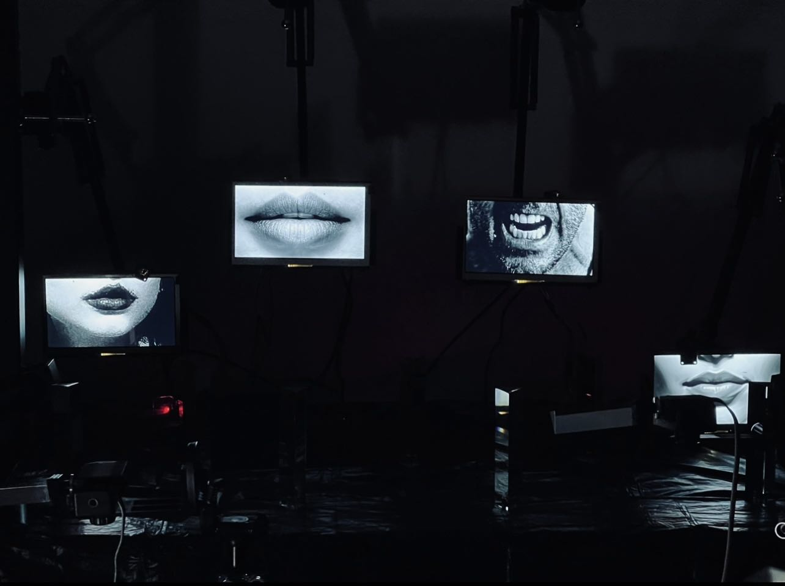

In conclusion, the project stands as a critical technical artifact within the scope of CTP, presenting a novel vantage point to engage with the discourse on emotional labor—a dialectic engagement that is simultaneously pedagogical, technological, and deeply humanistic.

1. Evaluation

The evaluation of the installation will encompass two distinct yet interconnected facets: the technical realisation and the aesthetic value. In terms of technical realisation, the focus will be on the complexity and efficacy of the servo-controlled trigonometry mechanisms. Critical to this assessment will be the examination of the precision and functionality of these mechanisms, the integration and responsiveness of the photoreceptive elements, and the synchronization and fluidity of the video playback controls. These technical components are instrumental in establishing the overall cohesion and thematic conveyance of the installation.

On the aesthetic front, the video component will be scrutinized for its capacity to intuitively convey the impact of emotional labor on educators. This aspect of the evaluation will delve into the video's effectiveness in reflecting both the nuanced emotional transitions experienced by teachers and the overarching artistic style that characterizes the installation. The aesthetic appraisal will thus provide insight into how the visual and narrative elements of the video resonate with the viewer, enhancing their understanding of the complex theme of emotional labor.

5.1 Self-assessment

5.1.1 Technical Realisation

Experimentation and Adaptation：In pursuit of an authentic representation under controlled lighting conditions, the device was tested in a late-night setting, mimicking a darkroom environment. The initial setup utilized a prism for refracting light along a predetermined trajectory. However, an observed limitation was that the rapid movement of the prism led to an insufficient duration of light exposure on the RGB color sensor. This resulted in a delayed or incomplete activation of the photosensitive element, thereby hindering the timely triggering of video playback. To rectify this, the servo speed was significantly reduced, allowing for a more effective interaction between the refracted light and the sensor.

Enhancing Emotional Representation through Interactivity:Further refinement was deemed necessary to authentically depict the multifaceted nature of emotional labor. Emotional labor, by its very nature, encompasses a spectrum of external emotions absorbed, transformed, and eventually released by educators. To better represent this diversity, the original design of using a fixed-angle light source was revised. The introduction of a graspable, user-controlled light source enabled participants to illuminate the prisms from angles of their choosing. This adaptation not only facilitated a more varied refractive pattern but also symbolized the diverse emotional experiences of teachers, thereby enriching the interactive aspect of the installation.

5.1.2 Artistic Value

Transition from Digital Art to Authentic Imagery: The initial phase of visual content creation involved utilizing the Midjourney platform for image generation. However, the output consistently gravitated towards a cartoonish aesthetic, which was incongruent with the intended message of the installation. These stylized representations created a disconnect with the emotional gravity of the video content, leading to a decision to move away from artificially generated imagery.

Ethical Utilization of Real Imagery: I have adopted a more immediately simple and direct method of replacing the images generated by the digital art, i.e. using real images. I used photographs of the mouths of close teacher friends, but of course this was done with consent and authorisation to ensure compliance with the ethical guidelines set out by the CTP. By using such real images, the transformation of emotions in the generated video will be more realistic.

Dynamic Video Generation with Runway: I chose to use Runway to generate videos to further highlight changes in emotional labour as well as to emphasise the impact of emotional labour on educators. This approach amplifies the subtle changes in teachers' emotional states, highlights the nature of emotional labour, and demonstrates the impact of emotional labour on educators' emotional well-being.

5.2 User experience feedback

In this section, we delve into the user feedback gathered from the interactive installation aimed at representing the emotional labor of educators. The feedback is pivotal in understanding the impact of the installation on the audience's perception and awareness of the often invisible emotional efforts exerted by teachers. This evaluation seeks to analyze the reflections, insights, and emotional resonances elicited by the installation, contributing to a deeper understanding of the significance of emotional labor in the educational sector.

5.2.1 Record of questions and answers

After experiencing this installation, what are your thoughts on the emotional labour teachers put in every day？

Luyang: "My personal experiences have made me cognizant of the emotional labor that teachers undertake. The multifaceted challenges they face, including diverse student needs, administrative pressures, and societal expectations, make their work particularly demanding. The difficulty in maintaining emotional neutrality in teaching is profound, with significant implications for both pedagogical effectiveness and the teachers' own well-being."

In the video, what emotions do you sense from the transformation of the smile, and how do you think this parallels the process of changing emotions in teachers?

Luyang: "The video conveyed a spectrum of emotional shifts, mirroring the dynamic nature of teachers' emotional experiences. While the video didn't explicitly visualize teachers' emotional transitions, the metaphorical transformation of emotions suggests that teachers assimilate and transform external emotional stimuli. An additional installation might better illustrate these subtleties within an educational context."

How did the interactivity of the installation, with lighting and video controlled by your interactive triggers, make you feel more connected to the idea of emotional labour?

Luyang: "The interactive trigger of light refraction intriguingly symbolizes the process of emotional labor. The direct engagement with the installation fosters a tangible connection to the concept, though continuous motion in the prism could enhance this effect further."

The device uses technology to evoke an emotional response; does this deepen your understanding of the often intangible emotional work that teachers do?

Luyang: "The use of light in the device, as both an input and a visual output, metaphorically represents the often invisible and intangible nature of teachers' emotional labor. This artistic approach effectively deepens the understanding of the nuanced and unseen aspects of their contributions."

How might this artistic expression of emotional labour affect your future interactions with educators?

Luyang: "This installation has enriched my appreciation of the unseen emotional labor of teachers. Recognizing their endurance and selflessness, my future interactions with educators will be grounded in profound respect and empathy."

Was there a moment during the installation that particularly struck you, or caused you to think about emotional labour in a significant way?

Luyang: "The use of light refraction as a metaphor for emotional labor was particularly striking. Light's straight-line journey, altered by a prism, symbolizes the transformation inherent in emotional labor. The scattered light represents the diverse impact of this labor, while the video's transformations echo the complex emotional states of teachers, prompting deeper contemplation on the subject."

How do you think such installations contribute to raising social awareness of the emotional labour of teachers?

Luyang: "Interacting with the installation undoubtedly raises awareness about teachers' emotional labor. It highlights how educators often absorb their students' emotional burdens, which can accumulate and adversely affect their own mental health. This societal issue, deserving of greater visibility, underscores the need for a collective acknowledgment and response to the emotional labor of teachers."

5.2.2 Feedback summary:

In this section I will explore the user feedback collected in the emotional labour interaction device. I will collect and summarise this feedback to reflect on the shortcomings of the stage device. At the same time, I will collect user perspectives on teachers' emotional labour and summarise the views as well as perceptions of teachers' emotional labour in the current context. This feedback assessment aims to analyse the reflections, insights and emotional resonance elicited by the device in order to deepen the understanding of the meaning of emotional labour in education.

1. Discussion

6.1 Technical Contribution

In this study, I demonstrate a variety of control and generative techniques that articulate the process and potential impacts of emotional labour. By utilizing optical techniques, I effectively control the refraction of light from a prism onto a photosensitive element. This design exemplifies the intricate interplay between light and technology, symbolizing the precision necessary for emotional regulation. Furthermore, the photosensitive element's role in controlling video playback is a testament to how light, when influenced by audience interaction, can directly alter media displays, fostering a dynamic and responsive environment. This aspect highlights the essential responsiveness and adaptive coping skills needed in the teaching profession, where emotional states must continuously adjust to evolving scenarios.

Despite these advances, the installation is not without its limitations in terms of sensitivity and video coherence. There exists considerable potential for further enhancements, such as integrating machine learning to interpret participants' emotions in real-time and employing more prismatic refractions to better represent the diversity of emotions. However, these improvements would entail substantial time and financial investment, particularly in training the machine learning models and fine-tuning the angles of the light prisms. Enhancing video generation for smoother and more coherent transitions also presents an area for future development.

The core techniques showcased in this study revolve around expressing the process of emotional labour through prismatic refraction and activating sensors to play videos that illustrate the impact of this labour. These achievements stem from a synergy of various methods, culminating in the creation of a comprehensive interactive device. While not all technological aspects of this device are original innovations, the application of light refraction through prisms as a means to simulate emotional labour is a novel approach in the artistic exploration of this theme. During my research, I found it rare for artists to use interactive devices to delve into the nuances of emotional labour. Additionally, I incorporated AI generation software like Midjourney and Runway to create the videos and relied on open-source frameworks to compensate for the absence of real-time emotion translation via machine learning.

By elucidating the principles behind my installation and demonstrating its operational mechanics, I aspire to foster a broader understanding of emotional labour, alongside an appreciation for the artistic and technical nuances of light prism refraction. This project serves as a stepping stone towards a more empathetic recognition of the unseen emotional efforts in professional settings, particularly in education, and lays the groundwork for future explorations at the intersection of art, technology, and human emotion.

6.2 Aesthetic Contribution

The installation's innovative use of light prisms serves as a profound metaphor for emotional labour, artistically encapsulating the complex emotional spectrum experienced by teachers. This metaphorical representation surpasses traditional artistic forms, offering viewers an immersive experience that symbolizes the delicate balance and emotional regulation inherent in the teaching profession.

The video component of the installation, depicting the transformation of a smile, unfolds a powerful visual narrative. This portrayal is not just a reflection of the teacher's emotional journey but also resonates deeply with the viewer. The imagery, both striking and thought-provoking, compels the audience to contemplate the often invisible emotional shifts that educators endure.

In unison, these elements not only highlight the emotional labour integral to teaching and learning but also elicit a profound emotional and empathetic response from the viewers. This project exemplifies the arts' capacity to capture and communicate intricate emotional realities, thereby paving the way for further exploration and discourse in this realm.

1. Conclusions & Future Work

In this paper, I aim to reveal and visualise teachers' emotional labour and its processes through a series of innovative interactive installations that reveal the often-overlooked dimensions of emotional labour in teachers' work. In these studies, I explored how the process of emotional labour can be demonstrated in innovative ways, and how changes in expression can bring awareness to the profound impact of emotional labour on teachers as well as provoke reflection. I chose to use the principle of light refraction combined with AI-generated expression changes as the core elements of the installation, integrating them skillfully into the overall installation, thus deeply reflecting the nature of emotional labour and its overlooked impact.

This project pushes the boundaries of interactive art in expressing social issues, proving that the combination of technology and art can effectively evoke empathy and understanding in the audience. In the future, I will dedicate myself to exploring in depth the effect of refracting light and shadow from the three prisms, making them richer in depth and connotation, and echoing each other. At the same time, I will use machine learning technology to improve the real-time interactive experience function in the installation, so that the audience can experience the various aspects of emotional labour in a more in-depth manner, as a way to call on the society to pay more attention to and think deeply about the importance of emotional labour in the teaching profession, to challenge the status quo and to think about a better and more rewarding future.

Bibliography

Parveen and Haleema (2019). Relationship Between Teachers’ Stress and Job Satisfaction: Moderating Role of Teachers’ Emotions. Vol. 34 Issue 2, p353-366. 14p.

Kariou, A., Koutsimani, P., Montgomery, A. and Lainidi, O. (2021). Emotional Labor and Burnout among Teachers: A Systematic Review. International Journal of Environmental Research and Public Health, 18(23), p.12760. doi:https://doi.org/10.3390/ijerph182312760.

Glazzard, J. and Rose, A. (2019). The Impact of Teacher well-being and Mental Health on Pupil Progress in Primary Schools. Journal of Public Mental Health, [online] 19(4), pp.349–357. doi:https://doi.org/10.1108/jpmh-02-2019-0023.

Arlie Russell Hochschild (2012). The Managed Heart. [online] University of California Press. Available at: <https://www.ucpress.edu/book/9780520272941/the-managed-heart>.

Anttila, E., Turtiainen, J., Varje, P. and Väänänen, A. (2017). Emotional labour in a school of individuals. Pedagogy, Culture & Society, 26(2), pp.215–231. doi:https://doi.org/10.1080/14681366.2017.1378708.

Konečni (2015). Emotion in Painting and Art Installations. The American Journal of Psychology, 128(3), p.305. doi:https://doi.org/10.5406/amerjpsyc.128.3.0305.

Philip E. Agre (1997). Toward a Critical Technical Practice. [online] pages.gseis.ucla.edu. Available at: <https://pages.gseis.ucla.edu/faculty/agre/critical.html>.

Rychlowska, M., Jack, R.E., Garrod, O.G.B., Schyns, P.G., Martin, J.D. and Niedenthal, P.M. (2017). Functional Smiles: Tools for Love, Sympathy, and War. Psychological Science, 28(9), pp.1259–1270. doi:https://doi.org/10.1177/0956797617706082.

Shayne, J. (2017). Recognizing Emotional Labor in Academe. [online] Inside Higher Ed. Available at: https://www.insidehighered.com/advice/2017/09/15/importance-recognizing-faculty-their-emotional-support-students-essay [Accessed 21 Nov. 2023].

Hochschild, A.R. (2022). The managed heart. Working In America, pp.40–48.

Previte, A. (2020). Recognizing the Emotional Labor of Educators. [online] Resilient Educator. Available at: https://resilienteducator.com/lifestyle/emotional-labor-of-educators/#:~:text= [Accessed 22 Nov. 2023].

Sutton, R.E. and Wheatley, K.F. (2003). Teachers’ Emotions and Teaching: A Review of the Literature and Directions for Future Research. Educational Psychology Review, 15(4), pp.327–358. doi:https://doi.org/10.1023/a:1026131715856.

Brotheridge, C.M. and Lee, R.T. (2003). Development and validation of the Emotional Labour Scale. Journal of Occupational and Organizational Psychology, 76(3), pp.365–379. doi:https://doi.org/10.1348/096317903769647229.

Yin, H., Huang, S. and Chen, G. (2019). The Relationships between Teachers’ Emotional Labor and Their Burnout and Satisfaction: A Meta-Analytic Review.

Grandey, A.A. (2000). Emotional regulation in the workplace: A new way to conceptualize emotional labor. Journal of Occupational Health Psychology, 5(1), pp.95–110. doi:https://doi.org/10.1037//1076-8998.5.1.95.

Hargreaves, A. (2000). Mixed emotions: teachers’ perceptions of their interactions with students. Teaching and Teacher Education, 16(8), pp.811–826. doi:https://doi.org/10.1016/s0742-051x(00)00028-7.

Mann, S. (2004). ‘People-work’: emotion management, stress and coping. British Journal of Guidance & Counselling, 32(2), pp.205–221. doi:https://doi.org/10.1080/0369880410001692247.

Chang, M.-L. (2009). An appraisal perspective of teacher burnout: Examining the emotional work of teachers. Educational Psychology Review, 21(3), pp.193–218. doi:https://doi.org/10.1007/s10648-009-9106-y.

Isenbarger, L. and Zembylas, M. (2006). The emotional labour of caring in teaching. Teaching and Teacher Education, 22(1), pp.120–134. doi:https://doi.org/10.1016/j.tate.2005.07.002.

Schutz, P.A. (2009). Advances in Teacher Emotion Research. [online] Available at: https://content.e-bookshelf.de/media/reading/L-6084-ad6585d105.pdf [Accessed 22 Nov. 2023].